# CS 255 System Design Document Template

This template lays out all the different sections that you need to complete for Project Two. Each section has guidance to prompt your thinking. You will need to continually reference the interview transcript as you work to make sure that you are addressing your client’s needs. There is no required length for the final document. Instead the goal is to complete each section based on what your client’s needs are. Remove this note when you are finished, and replace all bracketed text with the relevant information.

## UML Diagrams

### UML Use Case Diagram

**

### UML Activity Diagrams

### UML Sequence Diagram

### UML Class Diagram

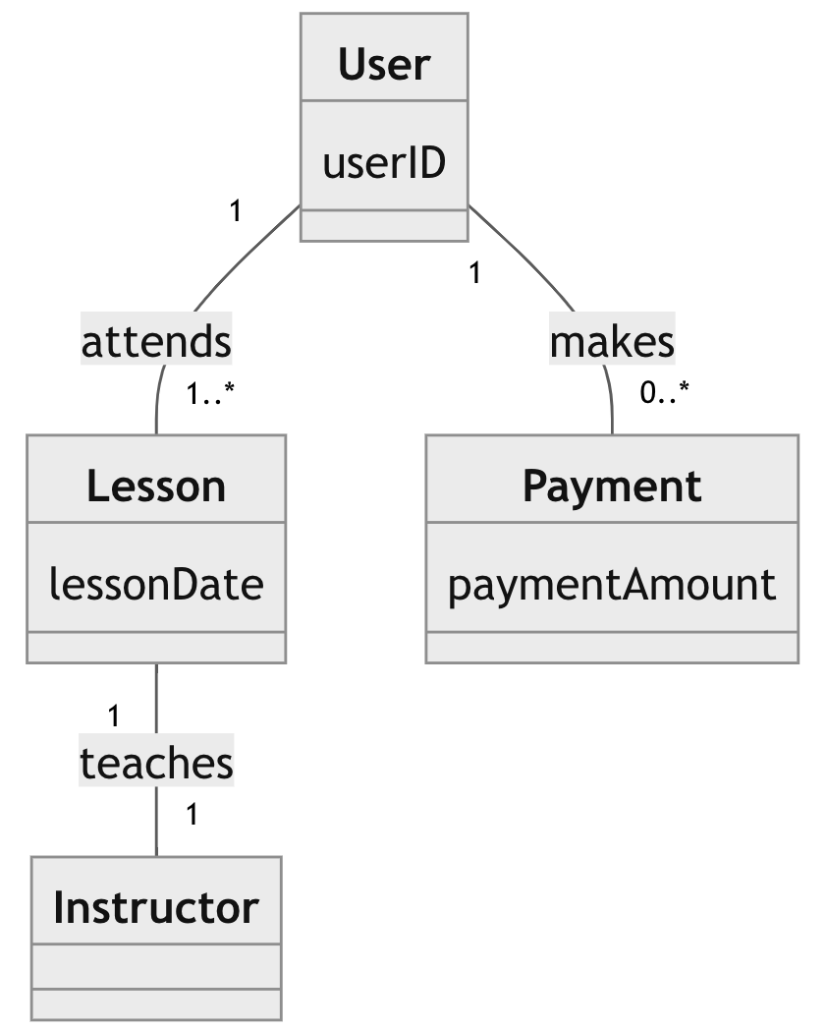

## Technical Requirements

*Hardware Requirements:*

*Servers: To support the web application, database, and payment processing.*

*Workstations: For the development team and administrative staff.*

*Mobile devices: For testing the mobile version of the application.*

*Software Requirements:*

*Operating System: Server OS for hosting the application, likely a Linux distribution for stability and security.*

*Database Management System (DBMS): To store and manage user data, booking information, payment records, etc.*

*Web Server: Such as Apache or Nginx to handle web traffic.*

*Development Environment: IDEs and code repositories for application development.*

*Tools:*

*Version Control: Such as Git for source code management.*

*Project Management: Tools like Jira or Trello for tracking progress.*

*Continuous Integration/Continuous Deployment (CI/CD): For automated testing and deployment.*

*Infrastructure:*

*Cloud Services: For scalability and reliability, possibly using AWS or Azure.*

*Payment Gateway: Integration for processing payments securely.*

*Security: Firewalls, SSL certificates, and intrusion detection systems to protect data and transactions.*